Title

Abstract
The aim of the article is to outline key elements of the street children subculture in Makeevka, Ukraine, with an emphasis on the functions of a subculture and its manifestations of collectivity. The research was based on qualitative and quantitative research conducted from 2000 to 2009. Data analysis suggests that collectivity functions on three different levels: inner-group, group and supra-group levels and that the subculture of street children combines elements of a classical subculture with those of a neo-tribe.

Key words: street children, subculture of street children, collectivity, Ukraine, Baltushka

Andrej Naterer
University of Maribor
Faculty of Arts
Department of Sociology
Koroska cesta 160
2000 Maribor
Slovenia
andrej_naterer@hotmail.com

Introduction

The aim of the article is to present ethnographic data gathered among street children in the Ukrainian city of Makeevka and to discuss some of the main features of their subculture.
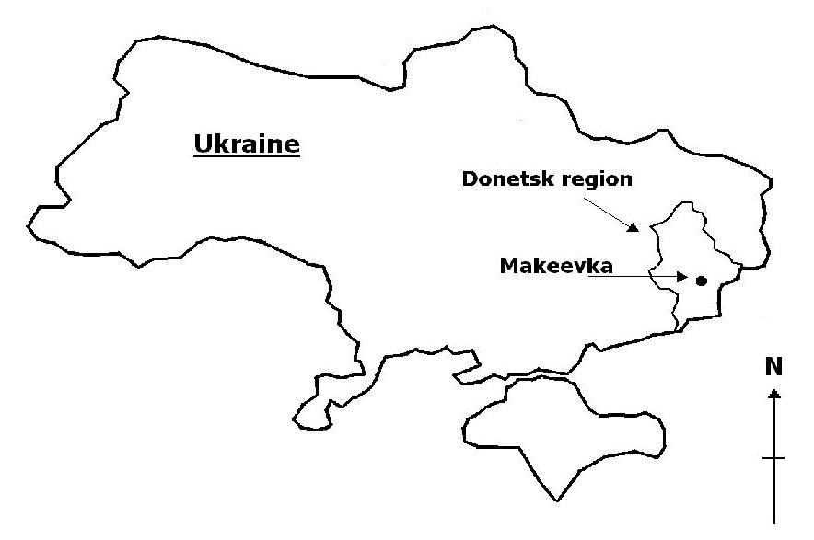
Figure 1 Ukraine, Donetsk region, Makeevka

The ethnographic data aims to add to the very few studies of street children subcultures in former Soviet countries (e.g., Stephenson, 2001; Lukašinska, 2002). Before Naterer's anthropological field research, street children in Makeevka had not been scientifically observed, described and analysed. During the longitudinal research, conducted between 2000 and 2010 and supervised by Prof. Godina, an enormous amount of data was collected. The data shows, among other findings, that for street children in Makeevka a non-typical subculture is characteristic.

The analysis here presented of the subculture of street children in Makeevka is based on classic knowledge of subculture, produced by the Chicago and Birmingham school, and on post-subcultural studies. The study also incorporates findings of other researchers who present different groups of street children as subcultures (e.g., Chitradub, 1998; Stephenson, 2001; Beazley, 2003a, 2003b) and street children as competent social actors (e.g., Aptekar, 1988, 1989; Davies, 2008). The findings of these studies provide the theoretical framework for analysis of the empirical data. The analysis of the data offers insight into the most characteristic features of the subculture of street children in Makeevka, consumption of Baltuska, for instance, as well as into the functioning of the subculture. It will also highlight the manifestations of collectivity on three levels: the level of the city (code Guliat’), the level of the group (the subculture) and inner group levels (Bomzhi communitas). The study also strives to extend the discussion on the socialization of children into street life, particularly through processes of integration.

Method

Data presented in this article was collected by Andrej Naterer in the years 2000, 2002, 2004, 2005, 2006, 2007, 2008 and 2009. The study was designed as an integration of qualitative and quantitative approaches; the data were triangulated, the main aim being to conduct a complete survey of street children’s day-to-day life. A non-random sample of 68 street children was chosen, observed and interviewed. The participants were living in four groups at four different geographic locations in the city: group no. 1 was living in the centre of Makeevka; group no. 2 was living in the suburban part of the city (10 km from the centre) - Ziljoni quarter; group no. 3 was living approximately 8 km from the centre of the city - Pushka quarter; and group no. 4 was living near the center of the city (see Figure 2).

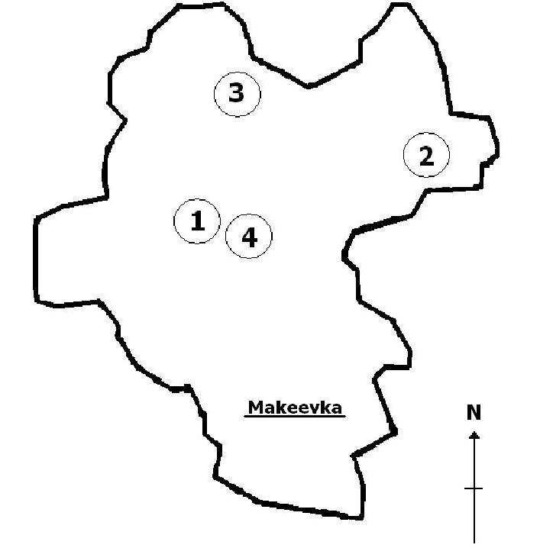
Figure 2 Location of the groups of street children in Makeevka

Each of the four groups studied has a specific social structure and group organization that is similar to the one presented by Lalor (1999), Lusk (1992) and Agnelli (1986).
Data collection was performed at locations that are occupied by street children:
  - in the centre of Makeevka: the main bus station, the Marshrutka station, the Pasazh shopping-mall, the Univermag shopping-mall, the central market and surrounding buildings;
  - in the Ziljoni quarter: the bus station, the central market and surroundings buildings;
  - in the Pushka quarter: the bus station, the restaurant, the market and surrounding buildings.

For the purpose of this study, three main methods were employed:
- participant observation (Burgess, 1993: 143–164; Flick, 2002: 139-141; Denzin, 2009: 185-186) – daily participant observation was performed on the street within participation in the group’s day-to-day life. Data was gathered mainly from interaction with street children in the form of field notes written as a diary, field report or conversation record;
- interview (Burgess, 1993: 101; Flick, 2002: 90-91) – a questionnaire with flexible, open-ended questions inquired about their current personal situation, family background, interpersonal relationships inside the group, living conditions on the street and their perspective on the future; a total of 68 children were interviewed;
- visual notes (Flick, 2002: 149-150) - using video equipment to create a series of video records of the children’s everyday life.
Additional methods were also employed:
- a questionnaire with pre-coded questions (Payne and Payne, 2004: 186–187) – used during field work in 2000 with the main aim of gathering sociographic and quantitative data;
- observation without participation (Flick, 2002: 135-136) – during field work on group number 3 in 2000, with the main aim of noting any differences between data gathered using participant observation and data collected by observation without participation.

All the data was triangulated in accordance with the procedures suggested by Bemak (1996), Aptekar (2000) and Bryman (2009). The process of triangulation was based on using at least three methods, mostly a combination of participant observation – visual notes – interview.

References

Inglehart, R. (1997) Modernization and Postmodernization: Cultural, economic, and political change in 43 societies. Princeton, New Jersey: Princeton University Press.
Magazine, R. (2003) ’Action, personhood and the gift economy among so-called street children in Mexico City’. Social Anthropology 11 (3): 303–318.
Muggleton, D., and R., Weinzierl (eds.) (2003) The Post-Subcultural Reader. Oxford, New York: Berg.
Shibutani, T. (1955) ’Reference groups as perspectives’, American Journal of Sociology 1 (11): 562–569.
UNECE (2010) at: www.unece.org (accessed 4.4.2010).
Weinzierl, R., and D., Muggleton (2003) ‘What is ‘Post-subcultural Studies’ Anyway?’, in D. Muggleton and R. Weinzierl (eds.) (2003) The Post-Subcultural Reader, pp. 3-23. Oxford, New York: Berg.

Makeevka is an industrial city in the Donetsk region, which has amalgamated with the city of Donetsk. Together the cities have approximately 2 million inhabitants. According to the 2001 census, there were 389,589 people living in the city (46% males, 54% females). Since street children were not submitted to the census, the exact number of children living on the streets in Makeevka is not known; some NGOs estimate the number to range from 1000 to 2000 (Naterer, 2010). After the attainment of Ukrainian independence in 1991, the processes of modernization, democratization and capitalization caused continuous decline in the national and local economy and living standard, which is particularly evident in urban areas of Eastern Ukraine. There was a 47% decline in GDP and a 25% increase in the adult mortality rate between 1990 and 2000 (WHO 2010) in Ukraine, and in five years, from 1995 to 2000 unemployment soared by another 85%, from 1,437,000 to 2,655,800 (UNECE 2010). One of the local newspapers from the Donetsk region reported in 2004, that the minimum survival income is in fact 40% higher than the officially guaranteed income, like minimum wages and pensions, for instance. In this respect the state of transition for many Ukrainians has been one of constant struggle for survival, forcing them to invent all sorts of additional survival mechanisms, from producing their own food in urban areas, to pawning goods or even adopting semi-legal and illegal economic activities.
The designations for groups evolved during the course of the research, meaning that the first group investigated was group number 1 in the centre. The next group discovered was group number 2, on the periphery of the town. The next group was group number 3, which is located between the centre and the periphery of the town. The last group discovered was group number 4.

